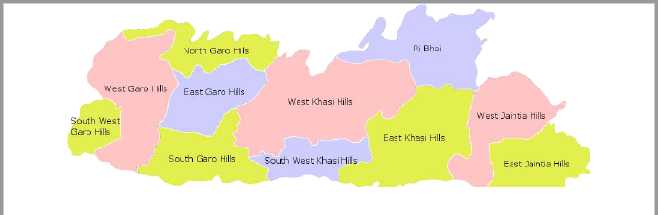**BLUE EARTHWORM:**

* Their emergence is probably triggered by the increased flow of water in rivers and streams, which indicates the arrival of the rains.
* The uphill migration starts with the onset of the monsoon in April-May.
* At this time, they emerge from the rivers and streams where they ‘overwinter’ under the rocks.

The downhill migration happens during September-October.

At this point, the vegetation begins to dry off and the temperature and humidity drop.

The timing is crucial for the downhill migration, as the worms fail to reach their favoured destination if there is any deviation in the ecological factors.

* In 2013, the rains had stopped abruptly in September-end, after a short burst of showers.
* That year, hundreds of earthworms died of desiccation before they could reach the water body–a gorge 300 metres downhill.

**Ecological Role**

•These earthworms play a role in enhancing the fertility of soil.

•Their activity on the East Khasi Hills, is helping the locals to shift to ecologically sustainable organic farming.

•Locals are shifting from conventional broomstick cultivation to grow organic tea that has gained in brand value abroad.

**The Threats**

•Unsustainable land-use practices have drastically reduced the population of earthworms in this region.

•The population of these earthworms is decreasing in areas where stone quarrying and earth-cutting has increased.

•Heavy earth-cutting is carried out in the East Khasi Hills, for road connectivity and village expansion

*Meghalaya has long seen a problem of rat hole coal mining, which affects the ecology of the area*

*The NGT had banned rat hole coal mining in 2014, because discharge from the mines was making the Kopili river acidic.*

**Rat hole coal mining:** In order to keep the mining price low locals have adopted these strategy to mine coal at less price.

It involves digging of very small tunnels, usually only 3-4 feet high, which workers (often children) enter and extract coal.

It is broadly of two types.

* In side-cutting procedure, narrow tunnels are dug on the hill slopes and workers go inside until they find the coal seam.

The coal seam in hills of Meghalaya is very thin, less than 2 m in most cases

* In the other type of rat-hole mining, called box-cutting, A rectangular opening is made, varying from 10 to 100 sq m, and through that is dug a vertical pit, 100 to 400 feet deep. Once the coal seam is found, rat-hole-sized tunnels are dug horizontally through which workers can extract the coal.

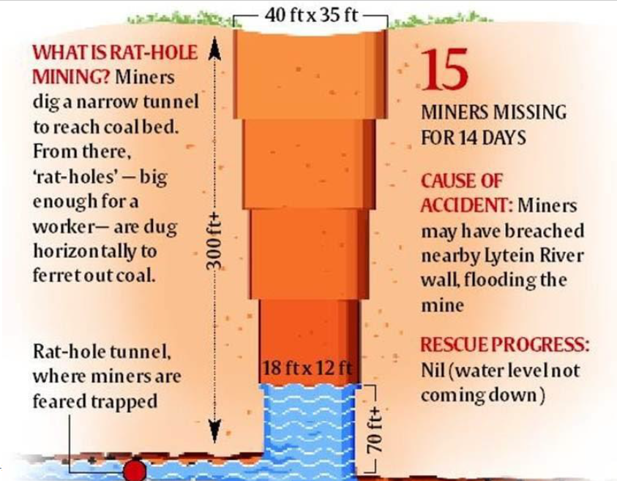

WHEN WAS IT BANNED, AND WHY?

* The National Green Tribunal (NGT) banned it in 2014, and retained the ban in 2015, on grounds of it being unscientific and unsafe for workers.
* The state government has appealed the order in the Supreme Court.
* Ecology: Entire roadsides in and around mining areas are used for piling of coal which is a major source of air, water and soil pollution.
* Risk to lives: There are umpteen number of cases where by virtue of rat-hole mining, during the rainy season, water flooded into the mining areas resulting in death of many… individuals including employees/workers.

**TO WHAT EXTENT IS THE PRACTICE FOLLOWED?**

* When the NGT ban was ordered, Meghalaya’s annual coal production was nearly 6 million tonnes.
* Almost all of it is said to have come through rat-hole mining.
* No other method would be economically viable in Meghalaya, where the coal seam is extremely thin.
* In Jharkhand, for example, the coal layer is extremely thick. You can do open-cast mining. But in Meghalaya this is the locally developed technique and the most commonly used one.

**BUDDHA STATUE:**

The ASI team has also found a reclining Buddha statue.

Officials have now confirmed the site as a major shrine.

•According to Buddhist beliefs, Lord Buddha himself travelled through the confluence of River Phalguin Gaya region, on the way to enlightenment. This is in present day Hazaribagh.

•In Buddhist legends, a popular monastery is said to have been located in Bahronpur.

•The ASI started working at the site after Buddhist monk Bhante Tiswarro revealed details about Bahronpur.

•Many residents in the area had found ancient idols in the area while constructing their houses, leading to the discovery of the place.

**Other Buddhist Sites in Jharkhand**

Itkhori – About 60 kilometres north of Hazaribagh.

➢Buddhist archaeological remains found.

➢Detailed sculpted statues of 104 Bodhisattvas and four statues of Buddha from 200 BC.

Chatra – Recently excavated Buddhist relics.

Dhanbad – Buddhist statues and an ancient pillar belonging to Ashokan times.

*The region was ruled by the Buddhist Pala dynasty in 8th Century to 12th Century, overthrown by Sena Dynasty.*

**Sena dynasty**

•Ruled Bengal in the 11th and 12th centuries CE.

•Their ancestors came from the south and established themselves as chieftains in south western Bengal early in the 11th century.

•Hemantasena, the founder of the dynasty, was originally a tributary of the Pala dynasty.

•In the mid-11th century he declared his independence and set himself up as king.

•His successor, Vijayasena(1095–1158), built an empire on the ruins of that of the Palas, gaining control of all Bengal and northern Bihar.

**WOMEN Co-Ownership Right:**

**The Need for the Reform**

Traditionally in the hilly areas of Uttarakhand, men are largely involved in heavy labour intensive work like ploughing the field.

* Women perform 90% of the farming related works.
* However, women do not get ownership of the land.

Under the existing Uttarakhand laws, the land ownership rights are transferred to the sons in the family.

If any woman applies for agricultural loan, they are denied because they do not have ownership of the land.

Uttarakhand has struggled with a huge problem of migration, over the last decade.

* 4.56 lakh moved out of the state in search of work.
* Most villages have elderly couples and women.
* Women are left to do household chores and work in the farm, without having any right to the land.

**Changes under the Ordinance**

* Inheritance–The new ordinance allows daughters to have inheritance rights on the land owned by her father.
* Ownership–A wife will be the joint owner of the land of her husband.

**Exceptions**

A divorced woman will not be the co-owner of the land that is in her first husband’s name.

* However, if the woman’s second husband is unable to provide for her financially, she would be allowed to co-own the first husband’s land.
* If a divorced woman does not have a child or her husband has been missing for at least 7 years, she can be the co-owner of the land owned by her father.

**Benefits**

* The move is aimed to financially help “women who are working in fields owned by their husbands or fathers especially in the hilly areas of the state.”
* With co-ownership of husband’s lands, women will be able to take agricultural loans.
* Will give equal partnership to women.

**Ordinances in the State Legislature**

* The Governor can promulgate ordinances (on the instructions of the State Council of Ministers) when the state legislature is not in session.
* He can also withdraw an ordinance anytime.
* These ordinances must be approved by the state legislature within 6 weeks from its reassembly.

*The Governor needs the President’s instructions to make an ordinance in three cases:*

* If a bill having the same provisions, would have required the previous sanction of the President for its introduction into the state legislature.
* If he would have deemed it necessary to reserve a bill containing the same provisions for the consideration of the President.
* 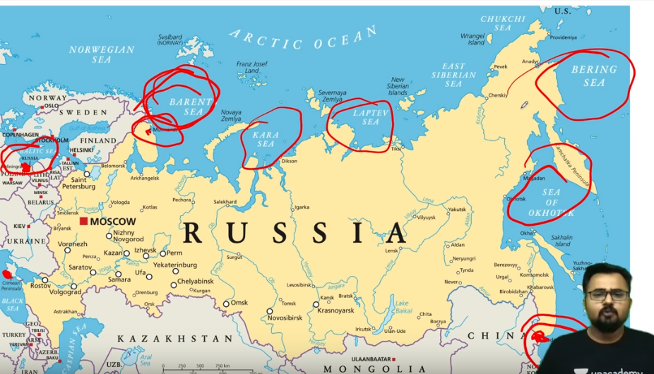If an act of the state legislature containing the same provisions would have been invalid without receiving the President’s assent.

**TAWANG RIVER PROJECTS:**

In April 2016, the National Green Tribunal had suspended the environmental clearance given to the proposed 780 mw NyamjangChu hydropower project, promoted by the Bhilwara Group.

This led to the state government cracking down on anti-dam protestors.

In May 2016, hundreds of people had gathered at the Tawang police station, demanding the release of arrested anti-dam activist LobsangGyatso.

* Two of those protestors had been shot dead on the spot, by the police.
* The state government had started an investigation into the police killings, but it was never made public.
* The project was put on hold after the SMRF sought the intervention of the National Green Tribunal, following fraudulent environmental impact studies.

The SMRF has repeatedly rejected environmentally damaging projects in the delicate Himalayan region of Tawang.

It says that the projects endanger several Buddhist pilgrimage sites.

In June 2017, the SMRF monks sent a formal closure report to the government of Arunachal Pradesh.

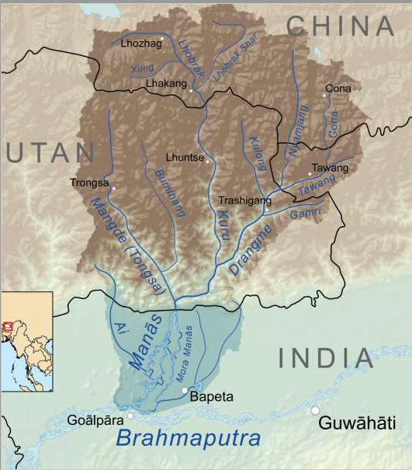*The report rejected:*

1. The 600 (3×200) MW Tawang Phase-I project and

2. The 800 (4×200) MW Tawang Phase-II project.

*Most of these hydropower projects are proposed to be constructed in the two major river basins in Tawang–*

➢The Tawangchhuin the east, and

➢The Nyamjangchhuin the west.

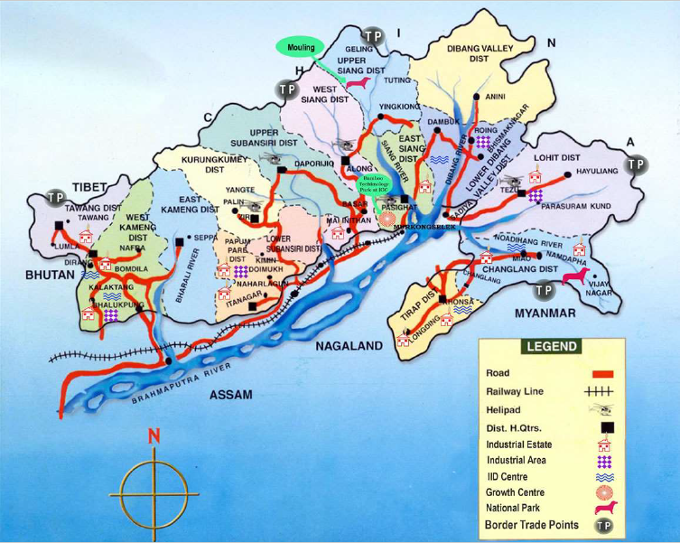

On 22ndFebruary 2021, the SMRF released a statement opposing the construction of hydro projects.

The statement reiterated SMRF’s earlier allegation that the signatures of the Gram Sabha for the TawangChu Stage-II were obtained fraudulently by the NHPC.

* Under the public consultation process, the concerns of local affected persons are taken into consideration while designing a project.
* The draft Environmental Impact Assessment Rules 2020, has expanded the list of projects exempted from public consultation.

**HIMALAYAN DAMS AND BIG HYDRO:**

Many large hydropower projects under construction in the Himalayan states, get delayed for up to 13 years.

➢Cost overruns as high as 200%.

➢Earthquake and landslide risks affect the construction process.

•The 3,097MWEtalinhydropower project in Dibang Valley is one of over 160 dam projects planned in Arunachal Pradesh.

➢It has attracted controversy over its impacts on wildlife and indigenous communities in the dense forests of north-east India.

**Q. HIMALAYAN DAMS AN ECONOMIC BURDEN?**

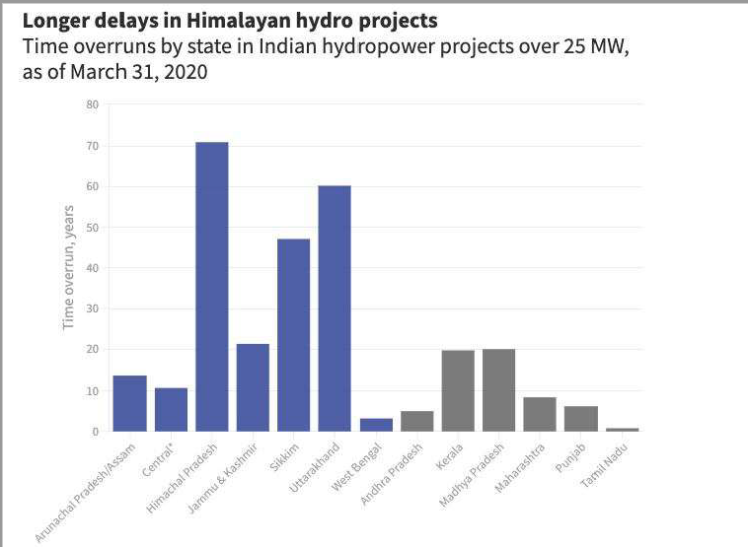

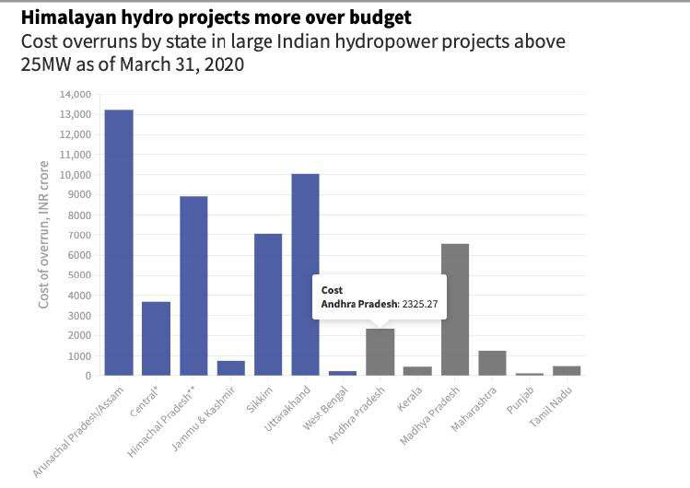

However, the central government continues to promote large hydropower projects in the Himalayas.

Reforms by the government in 2019:

➢Reclassified large hydropower (more than 25 MW capacity) as a renewable energy source, in order to make investment easier.

➢Also increased the debt repayment period to 18 years.

➢Government will pay for enabling infrastructure such as roads and bridges for some projects.

**SFURTI CLUSTERS FOR MSME:**

Former schemes merged with SFURTI:

* The Scheme for Enhancing Productivity and Competitiveness of Khadi Industry and Artisans.
* The Scheme for Product Development, Design Intervention and Packaging (PRODIP).
* The Scheme for Rural Industries Service Centre (RISC), and
* Other small interventions like Ready Warp Units, Ready to Wear Mission, etc.

Institutional Arrangement

1. Scheme Steering Committee (SSC) –Chaired by Secretary of the Ministry of MSME. Considers proposals and approves them.
2. Nodal Agencies (NAs) –Institutions with sectoral expertise, e.g.: KVIC is the NA for Khadi clusters.
3. Technical Agency (TA) –Assists NAs and SSC in implementing proposals.
4. Implementing Agency (IA) –Proposes clusters.

➢IAs can be NGOs, institutions of the Central and State Governments and semi-Government institutions, field functionaries of State and Central Govt., Panchayati Raj institutions (PRIs), etc.

➢Usually, one IA is assigned one cluster only.

➢The IA identifies and arranges suitable land for the project.

➢IA also appoints a full-time executive, to be located in the cluster, who will act as the Cluster Development Executive (CDE).

➢The CDE is responsible for implementation of the project.

**Who can Apply?**

•Non-Government organizations (NGOs).

•Institutions of the Central and State Governments.

•Semi-Government institutions.

•Field functionaries of State and Central Govt.

•Panchayati Raj institutions (PRIs).

Nature of Assistance

➢Maximum ₹8 crores financial assistancefor a single project.

Two types:

➢Regular Cluster (500 artisans) –Government assistance of up to ₹2.5 crore.

➢Major Cluster (more than 500 artisans) –Government assistance up to ₹5 crore.

*The artisans are organized into Special Purpose Vehicles (acting as implementing agencies), which can be:*

* a Society registered under Societies (Registration) Act, 1860,
* a Co-operative Society under an appropriate statute,
* a Producer Company under Section 465 (1) of Companies Act, 2013 (18 of 2013),
* a Section 8 Company under the Companies Act, 2013 (18 of 2013) or
* a Trust.

***In 2020, the World bank extended support to the COVID hit MSME sector of India***

50 clusters inaugurated.

•Ministry of MSME has funded ₹85 crores for these clusters.

•Over 42,000 artisans have been supported in the traditional segments of muslin, khadi, coir, handicraft, handlooms, wood craft, leather, pottery, carpet weaving, bamboo, agro processing, tea, etc.

**Suggestions:**

•The need for more research on what kind of village products are required by the consumers, and how to attractively design and market these products.

•National Institute of Design, Ahmedabad to improve the design and attractiveness of traditional products.

•A web portal, on the lines of Amazon or Alibaba, to market these products effectively, both in India and abroad.

•The need to speed up the formation of such clusters, since only 82 of the 371 announced so far are actually functional, while the target is 5,000 clusters.

**ISRO WARNING SYSTEMS:**

During the meeting, there was a brief discussion on the 7th February Chamoli floods in Uttarakhand.

* ISRO informed the Parliamentary Committee that satellite images were being used to analyse the reason for this sudden flooding.
* The ISRO officials informed the panel that there were no such landslide warning systems in place.
* Looking at the necessity to bring such systems in place, ISRO officials assured the committee that they will consider developing such a warning system.

***The Geological Survey of India has issued warning for glacial lakes in the seismically active and ecologically fragile Himalayan region***

***IIT Mandi signed an MoU with the district administration of Mandi district, Himachal Pradesh, for development and deployment of a Landslide Monitoring System in Mandi.***

**Warning system by ISRO**

1. IMD’s INSAT Warning System

* The Indian Meteorological Department (IMD) tracks cyclones though the INSAT Very High Resolution Radiometer imagery and Charged Couple Device Cameras.
* Warnings are issued to the Civil Administration (Collectors) of the areas that are likely to be affected by cyclones, through the INSAT Cyclone Warning Dissemination System (CWDS) receivers.

1. Distress Alert Transmitter (DAT) –

* INSAT (Indian National Satellite system) based.
* Used to transmit emergency conditions and position location to a central hub station via a UHF transponder, for rescue operations.
* Can be installed in boats and other vehicles.
* Mainly used by fishing boats.

1. DTH based Disaster Warning System

* The system can disseminate data Direct to Home (DTH) or to community centresand public places.
* Warning message originating station will select individual receiver or group of receivers.
* Receiver consists of a specially designed Set Top Box.
* Used by the agencies to broadcast warnings during emergencies such as cyclone, earthquake, landslide, flood and civil disturbances.

1. Doppler Weather Radar (DWR)

* Provides precise advance warnings.
* Aims to enhance the lead time for saving lives and property in the event of natural disaster associated with severe weather.
* Operated in the surveillance mode with continuous scanning either in clockwise or counter-clockwise direction.
* Provides quantitative information about the intensity and radial velocities of cyclones, area rainfall rate& accumulation.
* This improves the warning forecast.

**HYDROGEL FOR INSTANT HEALING:**

•This hydrogel has been derived from κappa-carrageenan.

It is a water-soluble polysaccharide found in:

➢edible red seaweeds and

➢a pigmented protein called C-phycocyanin found in Spirulina.

Spirulina is a biomass of cyano bacteria (blue-green algae) that can be consumed by humans and animals.

The three species of Spirulina are:

•Arthrospiraplatensis

•A. fusiformis

•A. maxima

Cultivated worldwide, Arthrospira is used as a dietary supplement or whole food.

•It is also used as a feed supplement in the aquaculture, aquarium, and poultry industries.

κ-carrageenan has a gelling property.

•C-phycocyanin = used as an injectable and regenerative wound dressing matrix.

•This will help to heal the wound rapidly and also to monitor it progress in real-time.

•The matrix developed was highly biocompatible.

•The scientists also confirmed the superior haemostatic (blood flow retarding) capabilities of the combination in traumatic injury conditions.

•The hydrogel matrix is fluorescent and therefore used in vivo Near-infrared (NIR) imaging.

➢Thus, it could help monitor the recovery of the wound by taking the time-lapse 3D images of the hydrogel filled wound.

➢Changing depth of the wound bed allows detection of the percentage recovery in wounds.

➢Such types of imaging can allow real-time monitoring of wound repair in internal injuries and diabetic patients where monitoring of wound repair is a challenge.

•The anti-inflammatory response and rapid blood clotting ability of κ-carrageenan-C-phycocyanin (κ-CRG-C-Pc) makes it very useful for rapid blood clotting, anti-inflammation, and appropriate monitoring of accelerated wound recovery.

C-phycocyanin provides an interconnected network of porous material with hydrophilic surface and mechanical stiffness.

➢This porosity allows transportation of nutrients and gaseous exchange across the wound healing site.

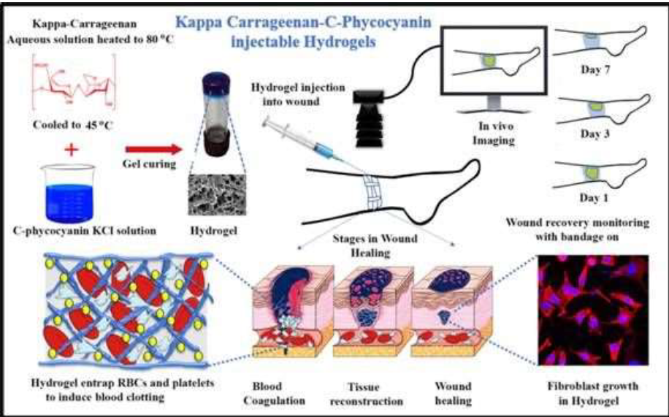➢This helps in the repair of cells.

**Uses:**

•The synthesized hydrogel will be highly beneficial for people of all age groups in wound healing applications.

•Its injectable property makes it the therapy of choice in tough to reach internal injuries, without opening the peritoneum of the patients.

•It can also be utilized in high altitude frost injuries, due to its self-healing properties.

* The team of INST scientists are now studying the mechanism of action of *κ-carrageenan-C-phycocyanin* (κ-CRG-C-Pc) hydrogeland its involvement in the signalling pathway.
* The aim is to explore the process of wound healing and regenerative properties.

**Recently, Indian scientists also developed a small molecule that disrupts the mechanism through which neurons become dysfunctional in Alzheimer’s disease (AD). It could be a potential drug candidate to treat Alzheimer’s.**

**The molecule could be a potential drug candidate to halt or cure the leading cause of dementia (70-80%) worldwide.**

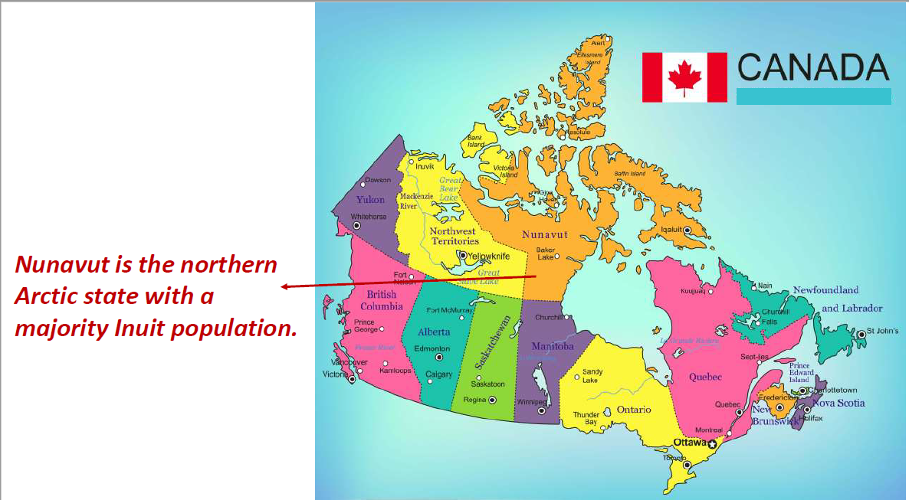**ENVIRONMENTAL RACISM:**

Inuit hunters worry that the mine expansion threatens wildlife, including marine mammals that communities depend on for food.

•Canada’s Arctic regions have little agriculture.

•Many Inuit in the area say that since more mine ships started arriving, whales and seals have been harder to find.

Baffin land Iron Mines Corporation wants to double its annual mining output to 12 million tonnes.

•To do this, it plans to build a railway and increase shipping through its port at Milne Inlet.

•The waters surrounding the port are a crucial habitat for narwhal in the Canadian Arctic.

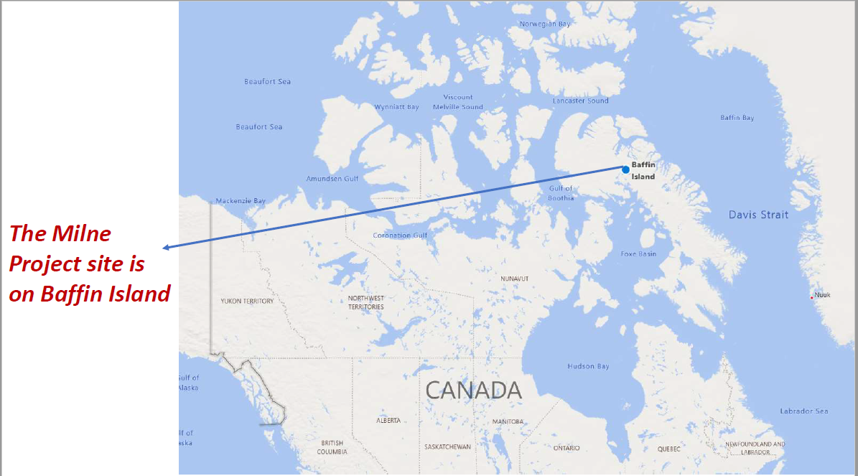

Hunters groups are concerned that caribou (rain deer) would not be able to cross a railway that is part of the proposed expansion.

➢Increased shipping will drive away marine wildlife.

➢Marine mammals are already changing their patterns with the current mine output, making hunting more difficult.

•The mining company, Baffin land has said that it's in communication with the hunting group and respects the right to peacefully protest.

*Iron dust from mining operations coats snow around cabin near the* ***Mary River mine*** *(Red colour).*

•Baffin land says that expansion of the mine is critical for its operations in the region to stay profitable.

•It believes that wildlife will not be affected by increased ore shipments.

•The company has also assured more than Canadian $2bn (₹11,500 crores) in royalties paid to Inuit over the mine’s 30-year lifespan.

Under the 1993 Nunavut Agreement, Baffin land is required to negotiate a benefit agreement with the Inuit groups that represent residents of the territory.

➢The Nunavut Agreement established key rights for the Inuit on their lands.

➢However, the protest draws attention to tensions between the Inuit ways of life (hunting-gathering) and the Mining organisations.

**Q. How Hazardous industries and mines are built close to the residential areas of the indigenous and black communities?**

1. **Examples of Environmental racism by Western mining companies**

* The Yanomami are the largest relatively isolated tribe in South America. Thousands of goldminers invade Yanomami territory.
* They live in the rainforests and mountains of northern Brazil and southern Venezuela.
* Since the gold from their territories is largely exported to India, the Yanomami people appealed to Indians, through a video, not to buy blood gold.

1. **Ok Tedigold and copper mine in Papua New Guinea**

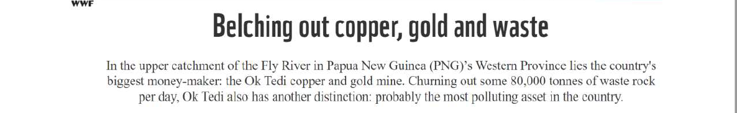

Owned by an Australian company –BHP Billiton.

* It extracted $6 billion worth of ore, over 12 years, and dumped 80 thousand tons of contaminated material–daily–into the Ok Tedi and Fly Rivers.
* After the mine was exhausted, the company admitted that it had vastly underestimated the environmental impact, turned over its shares to the government, and walked away.

The PNG government, already strapped for funds, was left to do the clean-up with their tax revenue.

The lives of 50 thousand people have been disrupted.

Many Such examples throughout the world.